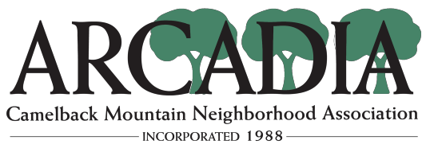

October 15, 2019

Zoning Hearing Officer
City of Phoenix, Planning and Development Department
200 W. Washington Street, 2nd Floor
Phoenix, Arizona 85003

Re: ZA-470-19, 4145 North 46th Place

Dear Sir or Madam:

With respect to (ZA-470-19) 4145 North 46th Place, The Arcadia Camelback Mountain Neighborhood Association does not oppose the two variance requests to reduce the required front yard setback (west) to 11 feet and to reduce the required street side setback (north) to 4 feet 2 inches. We would like to present our findings as it relates to the variances sought for the property.

The requests are consistent with existing builds within this triangular higher-density area south of the canal. The northern “street side setback” is an alleyway which passes eastbound to 47th. The property directly on the other side of the alley appears to have a similar 4-foot setback from the alley for a covered parking structure. Given the similarity of this request to neighboring conditions, it seems reasonable. The second request for the west side setback is not unlike many homes in the area and is like a variance request that was approved two months ago a few streets away. It seems this type of development is becoming the norm in the area and neighboring conditions have paved the way for this variance being accepted there.

On the morning of 10/15, I conducted a site visit and made attempts to contact neighbors. People were either fully supportive or just didn’t seem to care. This mix of support and apathy further removes our desire to oppose this request.

Thank you for allowing us the opportunity to provide our input.

Sincerely,

Tristahn Schaub
President, ACMNA
Chairman, Preservation Committee
www.acmna.org

